How Does Exercise Effect Blood Pressure?
Written By: Julia Elder
(December 7th, 2012)
Partner: Anna Eades
Experiment was conducted on December 4th, 2012

- Abstract
The purpose of this lab was to determine if exercise increased blood pressure of a human compared to the blood pressure of the individual at rest. The objective of this lab was to observe the blood pressure while at rest and during time of activity. The hypothesis of this specific project was that the blood pressure would be higher during exercise due to the fact that hear heart has to pump blood quicker to parts of the body that are taking strenuous forms. This hypothesis was, in fact, supported by the data. The key techniques used in the experiment were resting for one and a half minutes, exercising for one and a half minutes, and properly recording blood pressure.
- Background
Upon research, it is evident that this experiment has been conducted prior to the experiment of December 4th, 2012. In 2007, a man by the name of Andy conducted this experiment for he has noticed that his blood pressure had decreased dramatically upon losing a drastic amount of weight. His blood pressure went from around 140/90 to 115/70. Between the two blood pressure marks, he had been physically trained and was involved in an aerobics class. Due to all the exercise, he lost weight and considered himself “fit.” Andy wanted to conduct his own experiment to see how blood pressure was affected by exercise. He did a seven minute workout while seated, took blood pressure directly after, rested for three minutes, and then proceeded to work out while he stood up. After exercise, Andy concluded that his heart rate increased. With knowledge obtained from class, the heart rate increases to increase the flow of blood around the body to increase oxygen distribution and increases release of carbon dioxide from tissues can take place. Results concerning blood pressure did not have a drastic effect. There was slight increase in diastolic and systolic blood pressure.
In class, students learned that the blood circulates through the right atrium, tricuspid, right ventricle, pulmonary valve, pulmonary artery, and then to the lungs where oxygen is then put into the blood. Once that occurs, the blood travels pulmonary veins, left atrium, mitral valve, left ventricle, aortic valve, aorta, and then to the body. The body deprives the blood of oxygen. Muscles need a great amount of oxygen usually, but during exercise, they need even more. Thus, the heart needs to pump quicker.

- Hypothesis
The blood pressure of Anna will be higher during exercise than at rest.

- Materials and Methods
- Recording journal and pen
- Chair
- Room to exercise
- Timer
- Computer with Vernier Loger Pro software
- Vernier Blood Pressure Sensor
- Vernier LabQuest Mini with USB cable
- Sphygmomanometer
- Stethoscope
The procedure began with obtaining the a sphygmomanometer. Place the cuff snuggly on the forearm, approximately one inch over the elbow. The tubing should run down the inside of the arm. Clip the pressure gauge on the cuff, pace it on the table or lab bench, or hold it in hand so the values can be clearly seen. Put the stethoscope with the ears and slide the disc ¼ to ½ of the way under the cuff. Inflate the blood pressure cuff by pumping the bulb. When the blood pressure cuff is inflated enough to stop the blood flow, there should be no sounds in the stethoscope. Slowly deflate the cuff by gently turning the release valve. Listen for the heart beat. Record what number is on the gauge when the heartbeat is first heard, that will be the systolic number. Listen for when a heartbeat is no longer heard, and that will be the diastolic.
Now that the blood pressure has been manually recorded, the blood pressure needs to be electronically recorded. Manually recording will prepare one to record blood pressure when electronic equipment is not present. Make sure the equipment is connected to the computer. Open the logger pro software, blood pressure program, and then click on the human Physiology with Vernier folder. Open the program titled 07 Blood Press Vital Sign. Connect the Labquest mini to the computer using the USB cable. Connect the LabQuest mini. Wrap the blood pressure cuff around your partner’s upper arm. Position the person whose blood pressure is being taken so that they are seated with an arm resting on the table. Set the timer for one minute and thirty seconds. Make sure the individual is completely relaxed, and then proceed to start timing the individual. Immediately press the start button on the computer when the time is completed to being testing. Record systolic and diastolic when testing is complete. Then, carefully remove the cuff from the arm, set time for one minute and thirty seconds, and then press start when the individual beings to exercise (jumping jacks, running, jogging, etc.). Immediately place the cuff back on when the individual’s exercising period is over. Press start on the program, and record systolic and diastolic when testing is complete. Complete this procedure multiple times (with the same type of exercise) to ensure more accurate results.

- Results
As evident in the graphs below, the blood pressure increased after exercise. After resting for one minute and thirty seconds, Anna’s blood pressure was 110 mm Hg/ 61 mm Hg. After exercising, Anna’s blood pressure was 134 mm Hg/71 mm Hg.
Graph #1: At Rest
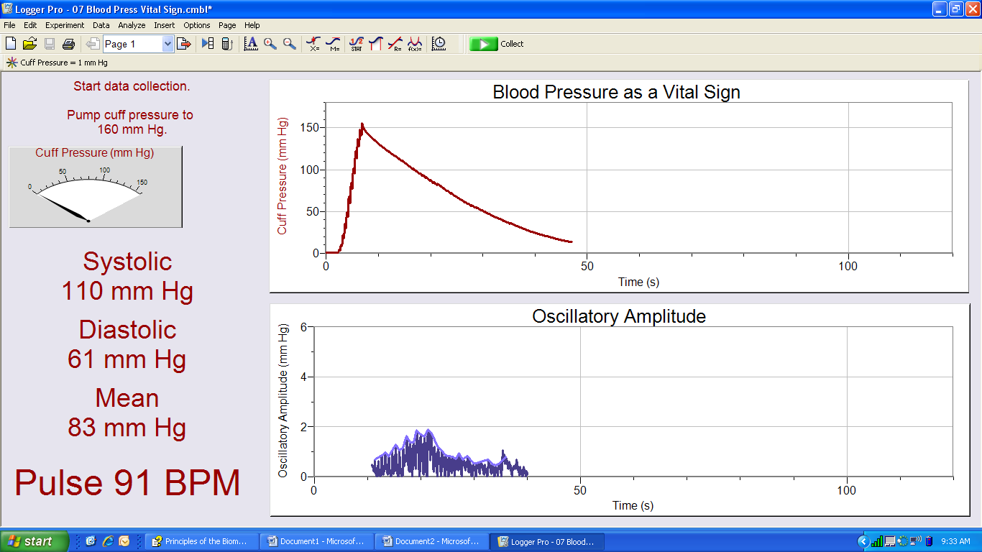

Graph #2: Exercise
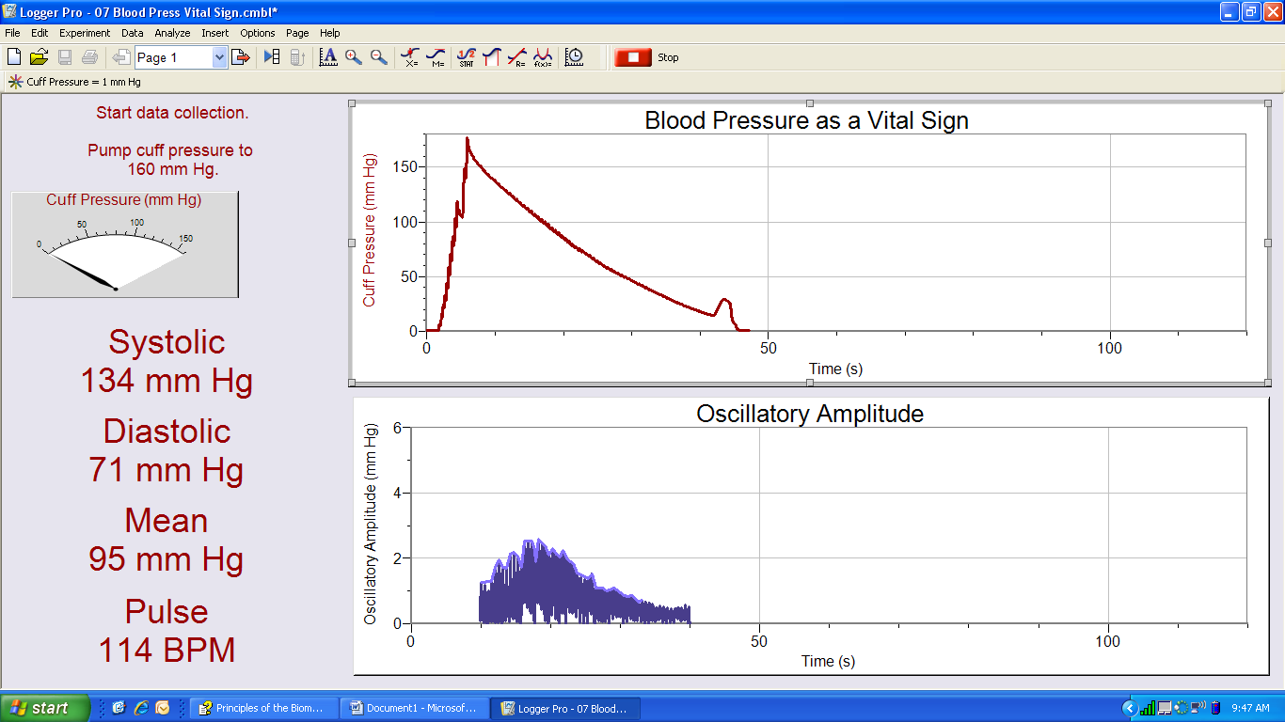

- Discussion
Anna’s blood pressure at rest was 110 mm Hg/61 mm Hg. After exercising, it was 134 mm Hg/71 mm Hg. Therefore, her systolic increased by 24 mm Hg and her diastolic increased by 10 mm Hg. The results that the data tables represent support Andy’s experiment. His blood pressure was higher when standing up since he was working more vigorously than while sitting down.
There were three errors presented in this particular experiment. First, the fact that the cuff had to be placed on after exercising when the cuff was already on the arm ready to test after resting. Also, the placement of the cuff could have differed each time the cuff was replaced on the arm. The most evident error was the fact that the variables were only tested once due to time purposes. If this experiment was conducted again, certain precautions can be taken. Unplugging the cuffing from the computer and leaving it on the arm while exercising is a feasible solution to the first situation. Also, marking the locations of placement of the cuff on the arms is a solution. Making sure there is enough time to conduct a well planned experiment is a must-have, too.

- Conclusion
The blood pressure increased when the certain individual exercised from when they were resting; systolic increased 24 mm Hg and the diastolic increased 10 mm Hg.

- Citation
NA, Andy et. al. (2008). Effects of Exercise on my Blood Pressure. One Twenty Over Eighty. Retrieved from: http://onetwentyovereighty.com/blood-pressure-experiments/effects-of-exercise-on-my-blood-pressure/

